Skill 1(Operating System)
Code:
#include <stdio.h>
#include <stdlib.h>
#include <unistd.h>
#include <sys/wait.h>

int main()
{
pid_t pid;

printf("=== Process Management Demo ===\n");
printf("Parent Process ID: %d\n", getpid());

pid = fork();

if (pid < 0)
{
perror("fork failed");
return 1;
}

if (pid == 0)
{
// Child process
printf("\n--- Child Process ---\n");
printf("Child PID: %d\n", getpid());
printf("Parent PID: %d\n", getppid());

printf("Executing 'ls' command using exec()...\n\n");

execlp("ls", "ls", "-l", NULL);

// This executes only if exec() fails
perror("exec failed");
exit(1);
}
else
{
// Parent process
printf("\n--- Parent Process ---\n");
printf("Parent PID: %d\n", getpid());
printf("Child PID: %d\n", pid);

wait(NULL);

printf("\nChild process completed.\n");
printf("Parent process exiting.\n");
}

return 0;
}
Output:
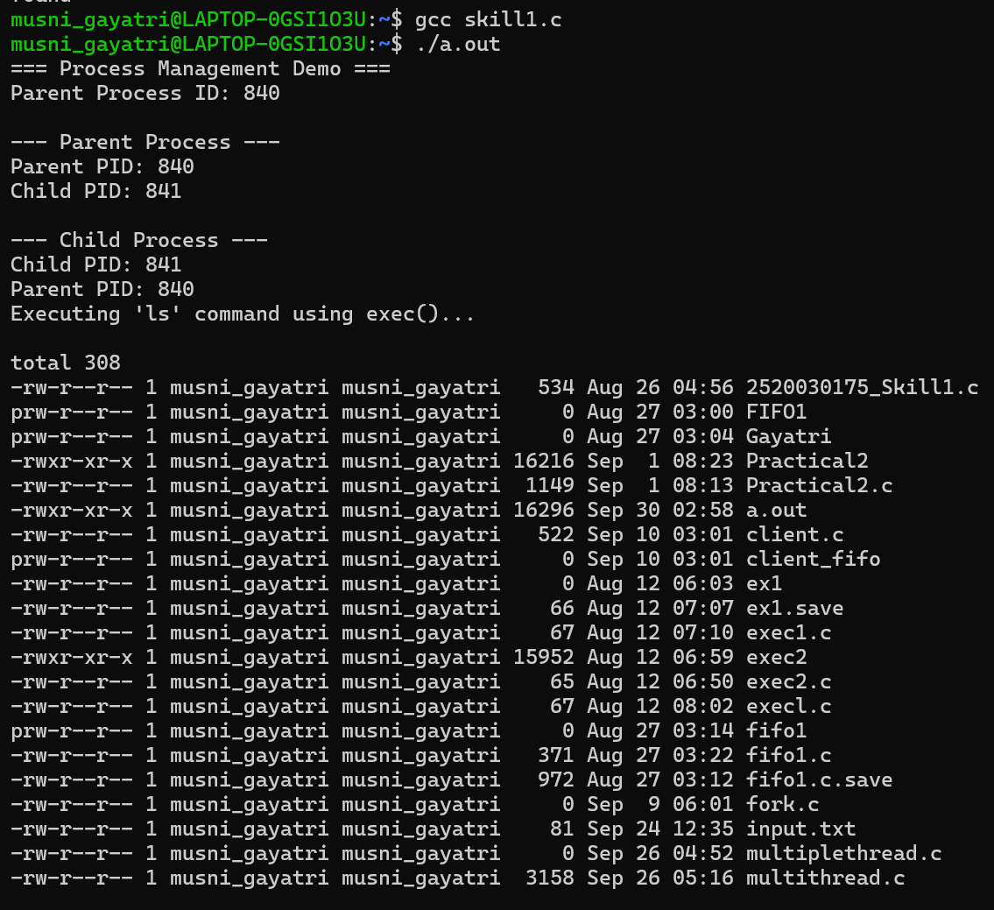
S